GeoGrab User Guide
Revision 1.3 - Last Updated – 09/28/2020
Developed by GeoEngineers
  - GeoGrab is a mobile application which allows for creating, editing, and exporting of maps using Android and iOS. The following document outlines using the basic features of the application.
Contents
Projects 3
Create a new project 3
Edit or delete a project 5
Open a saved project 5
Export a project (native GeoGrab project file (.ggproj) or KMZ) 5
Import a native GeoGrab project (.ggproj) 6
Import a KMZ or KML file 6
Cache a project’s map offline 7
Features Types 7
Define a new feature type: 7
Edit or delete a feature type: 8
Apply a custom style to a feature type: 9
Folders 10
Create a folder 10
Edit a folder 10
Move a folder 11
Delete a folder 11
Change the visibility of a folder 11
Features 12
Create a point 12
Move a point 13
Create a line/polygon 14
Adjust a line or polygon vertices 14
Add new points to an existing line or polygon 14
Delete a feature 15
Edit a feature’s info 15
Edit an individual feature’s style 15
Toggle an individual feature’s visibility 16
Feature Type Library 16
Create a Feature Type that can be added to a project 16
Edit or delete a User Defined Feature Type 17
Measurement tools 18
Measure the distance to yourself 18
Measure the distance between two points 19
Create a line following the user’s path 19
Technical Support 20

Projects
Projects act as the core of GeoGrab maps. Projects consist of a defined region and a collection of features (points/lines/polygons/misc. features) on a map.

Create a new project
- Tap the “Menu” button:
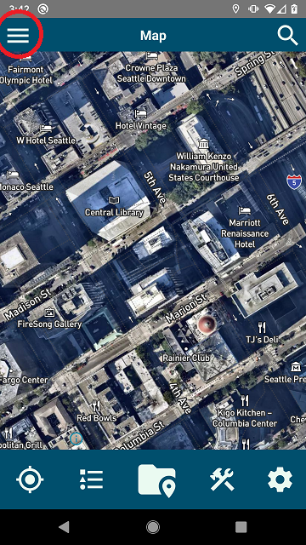
- Select “Projects”:
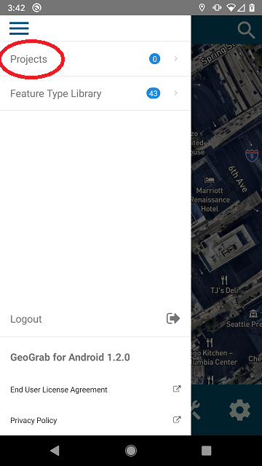
- Tap “New Project”:
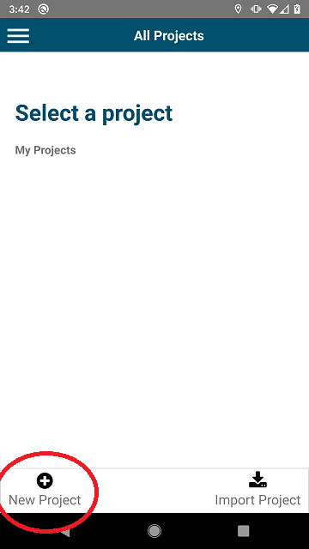
- Enter a name, project number, and select a project region. You may also add client and custom information:

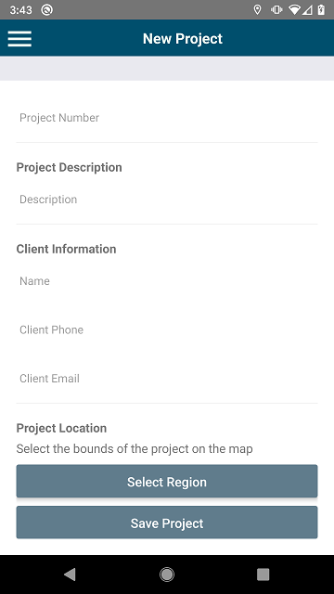

- Once entered, press “Save Project” at the bottom of the screen. This will take you back to the project selection screen.

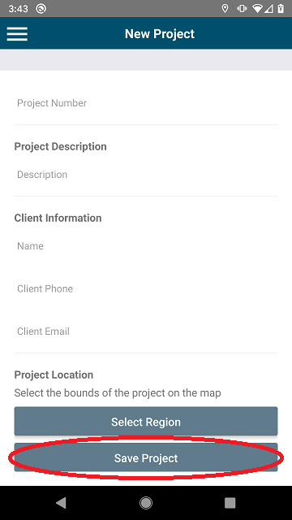

Edit or delete a project
- Tap the ellipsis to the right of the project details:
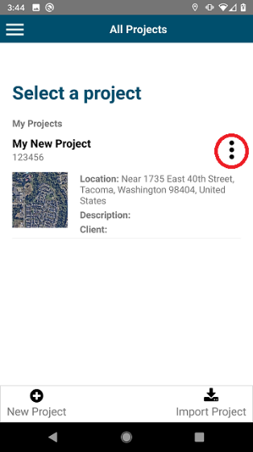

Open a saved project
- Open the project selection screen.
- Tap the project you’d like to open.
  - This will open the project in the map editor view. To use the features options, see the “Features” section below.

Export a project (native GeoGrab project file (.ggproj) or KMZ)
In addition to creating and editing projects, you may also save projects as either a native GeoGrab project file (.ggproj) or KMZ file. To export a project, do the following:
- Tap the ellipsis to the right of the project details.
- Click either “Export KMZ” or “Export GeoGrab Project”.
  - An alert message will prompt you with the location with the save location of your file.

Import a native GeoGrab project (.ggproj)
- Tap the “Import Project” icon in the projects screen.
  - You will be presented with a file selection interface.
- From the file selection interface, select your GeoGrab project.
  - If you are on iOS (Apple) you will be presented with the option to import from iCloud.

Import a KMZ or KML file
GeoGrab comes with basic support for KMZ and KML files. This currently includes importing of points, lines, and polygons, along with complex geometry. Image overlays and folder support are planned for a future release.
- Open a project.
- From the map view, select the “Project Features” icon:
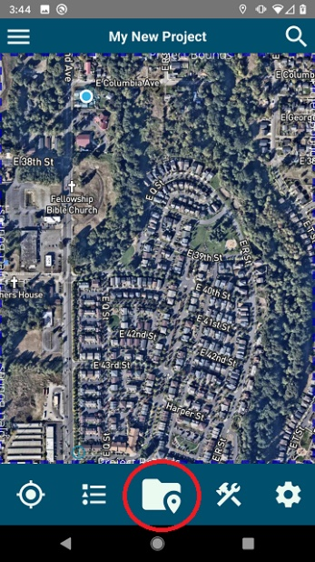
- Inside of the “Project Features” view, tap the ellipses next to the top bar.
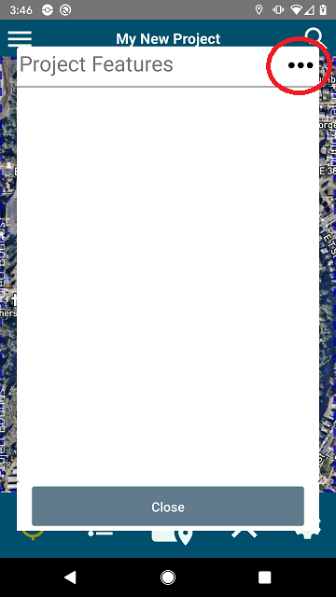
- Select the “Import KMZ Document as folder” menu item. From this menu, you will be presented with a file picker.
- Select your KMZ or KML file. It will be added to the feature type layer list as its own feature layer.
  - NOTE: Complex geometries can be imported from KMZs. However, editing these feature types are limited to feature info and color styles only. More information related to KMZ and KML files can be found at the following link: https://developers.google.com/kml/documentation/kmlreference

Cache a project’s map offline
- Navigate to the projects screen.
- Tap the ellipsis to the right of the project details.
- Click “Make Offline”.
  - A progress bar will appear indicating the project download progress.
  - WARNING: Do not close the application during this process. This may lead to the file failing to download and not being re-downloadable. A fix for this issue is being investigated.

Features Types
Feature types represent the various types of points, lines, and polygons within the application. Users can define feature types to be added to a project map within GeoGrab.

Define a new feature type:
- Open a project and select the “Manage Project Features Types” view by selecting the icon in the image below:
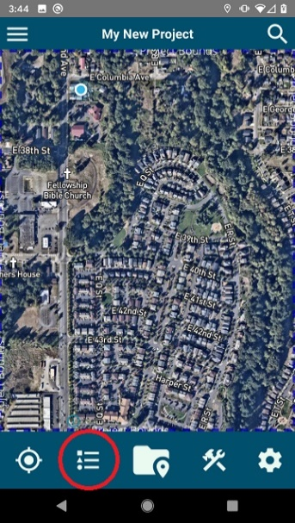
This will open the feature types table. You will see all current feature types within the application and two buttons at the bottom:
- “Add a new Feature Type”
- “Copy From Feature Type Libarary”
See the Feature Type Library section below for more info.
- Select “Add a new Feature Type”.
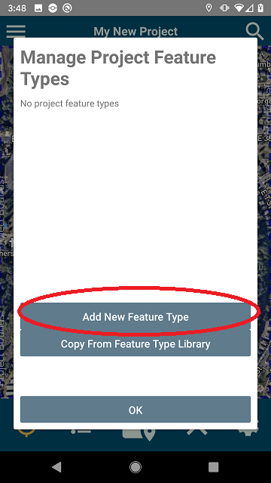
- Enter the name, feature class (shape type), style customizations, and custom fields.
- Tap “Save Feature Type”.
  - The new feature type will appear in the “Features Types” table.

Edit or delete a feature type:
- Select the “Manage Project Features Types” view.
- Tap your feature type.
  - To Edit, enter your updated feature information and tap “Save”
- To Delete, scroll to the bottom of the edit screen, tap “Delete Feature type”.
    - WARNING: This will delete all features which exist in the project of the selected feature type

Apply a custom style to a feature type:
- Select the “Manage Project Feature Types” view.
- Tap the feature type you would like to edit.
- Tap the button labelled “Edit Feature Type Styles”
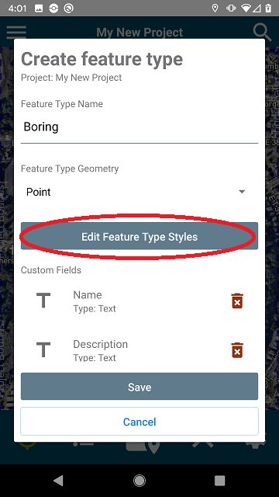
- From here you will see the style editor screen. You may apply relevant style information depending on the feature type. When done, press “Save Settings” (or the “X” to exit without saving):
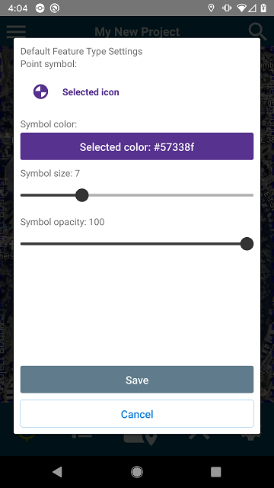

Folders
Folders allow you to organize your various feature types within the application. They can be added, edited, moved, and deleted.

Create a folder
- Select the “Project Features” view.
- Tap the ellipses (either on the top bar, or on a folder if one already exists)
- Select “Add Folder”.
- You will be prompted with a screen asking you to enter a folder name. Enter a new folder name and select “Save Folder”

Edit a folder
- Select the “Project Features” view.
- Tap the ellipses next to the folder you’d like to edit.
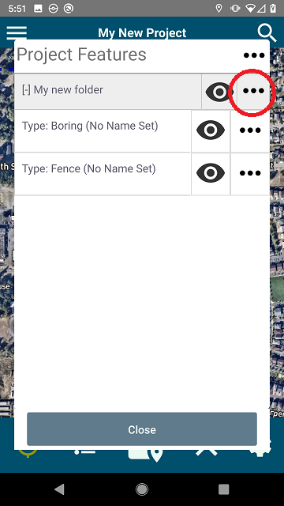
- Select “Edit properties”.
- Make any changes from the “Edit Folder” view.
- Tap “Save Folder”

Move a folder
- Select the “Project Features” view.
- Tap the ellipses next to the folder you’d like to edit.
- Select “Move Folder”.
- You will be prompted with all folder locations, tap the new location for the selected folder.

Delete a folder
- Select the “Project Features” view.
- Tap the ellipses next to the folder you’d like to edit.
- Select “Delete Folder”.

Change the visibility of a folder
- Select the “Project Features” view.
- Tap the eye icon next to the folder you’d like to toggle the visibility for.
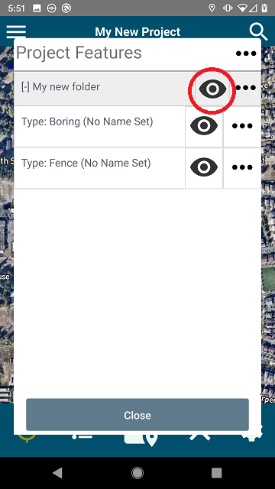

Features
Features are the actual data within the application. Features consist of points, lines, or polygons with additional details related to the feature itself such as Name, Description, etc.

Create a point
- Select the “Project Features” view.
- Tap the ellipses (either on the top bar, or on a folder – see section above for folders) and select “Add a feature”
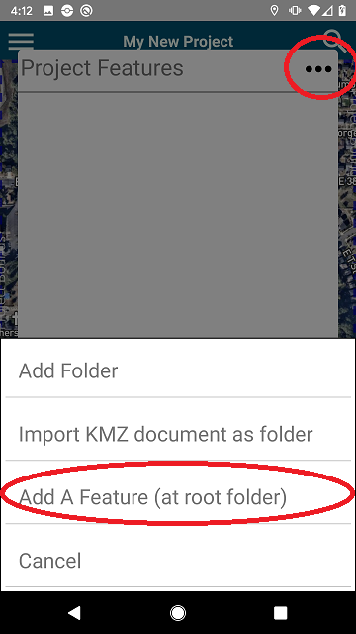
- Select a (point) feature type from the feature types list.
- A point will automatically be added to the map screen.
  - To change the location of the point, tap the “move point” (See below for details on moving points) icon.
- Click the save button to save the point:
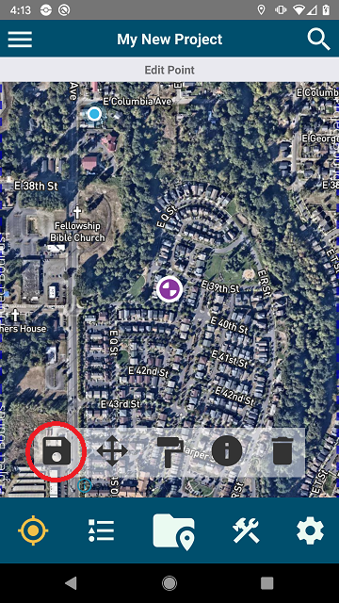
- Click the delete button to remove the point:
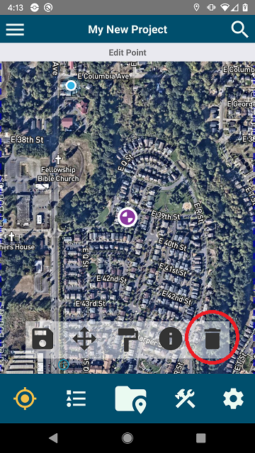

Move a point
- Tap a point.
- Tap the cross-arrows (“Move Feature”) icon
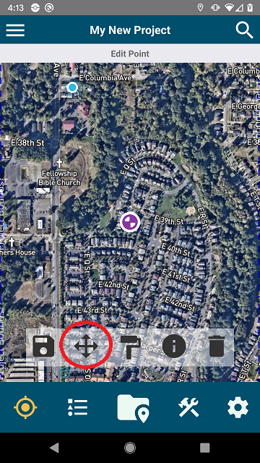
- You may drag the screen and the point will stay locked in place
- Alternatively, you may drag the point and move it manually. You can also use the lat/long box that appears at the top of the screen to manually enter coordinates.
- You may also tap the “To Me” button in the top left corner of the screen to immediately move the point to your current coordinates.
  - NOTE: Location services should be enabled to use the “To Me” feature.

Create a line/polygon
- Select the “Project Features” table.
- Tap the ellipses next to the top bar, or next to a folder name.
- Select the “Add a feature” option.
- Select a feature type.
- Tap the map where you’d like the first point of the feature.
- Tap again to add another point.
  - You may also tap “To Me” to move a point to yourself at any time during this process.
- Continue adding points until the designed object is created.
  - NOTE: Polygons will automatically close when you click the “Save” button.
- Click the “Save” button to save the feature.

Adjust a line or polygon vertices
- Tap the line or polygon.
- Select the “Move Feature” button.
  - The selected shape’s vertices will appear on the map. They may be selected and then moved in the same manner as points.
- Tap the “Save” button to save the updates.

Add new points to an existing line or polygon
- Tap the line or polygon.
- Select the “Move Feature” button.
- Select the plus symbol (“Add Point”) button. The selected shape’s vertices will appear on the map.
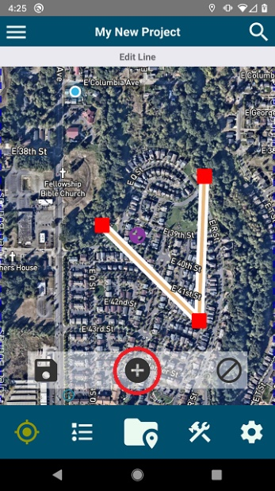
- Tap the lines making up the shape to add a new point to the line.
- You may add another point by tapping the “Add point” button again.

Delete a feature
- Tap a point, line, or polygon to select it.
- Click the delete button.
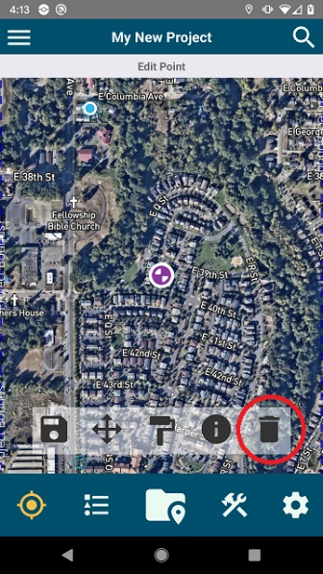

Edit a feature’s info
- Tap a point, line, or polygon to select it.
- Tap the “feature info” button. This will display the selected feature’s info.
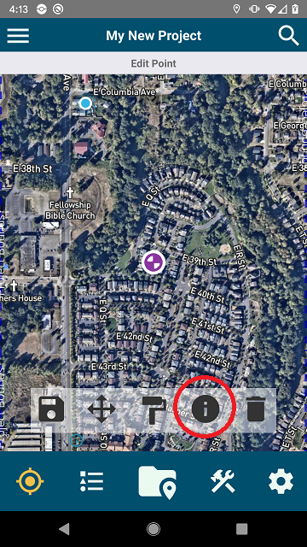
- Enter the information and press “Save” when complete.

Edit an individual feature’s style
Sometimes you may want to override the default style information for a point, line, or polygon. This can be achieved by following the steps below.
- Tap a point, line, or polygon to select it.
- Select the “paint brush” icon.
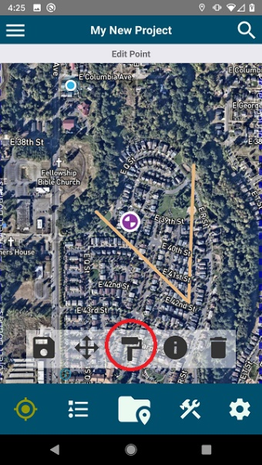
- You will be presented with the “style editor screen”. From here you may make any chances to the feature and then when completed, press the “Save” button.
-OR-

- Select the “Project Features” icon on the toolbar
- Tap the ellipses next to a feature.
- Tap “Edit Feature Style”
- You will be presented with the “style editor screen”. From here you may make any chances to the feature and then when completed, press the “Save” button.

Toggle an individual feature’s visibility
- Select the “Project Features” icon on the toolbar.
- Tap the eye icon next to a feature name.

Feature Type Library
Feature types are templates for points, lines, and polygons. The feature types library contains feature types that will likely be added to multiple projects. They are stored globally and changing these values will not directly impact your project points, lines, and polygon feature types which have already been added to projects.

Create a Feature Type that can be added to a project
- Tap the “Menu” button.
- Select “Feature Type Library”.
- Tap “New Feature Type” on the bottom of the screen.
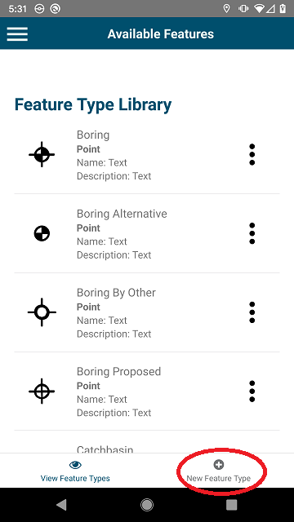
- This will take you to the feature editor user interface. You can enter a feature name, type, and custom fields which can be entered on project points, lines, or polygons.
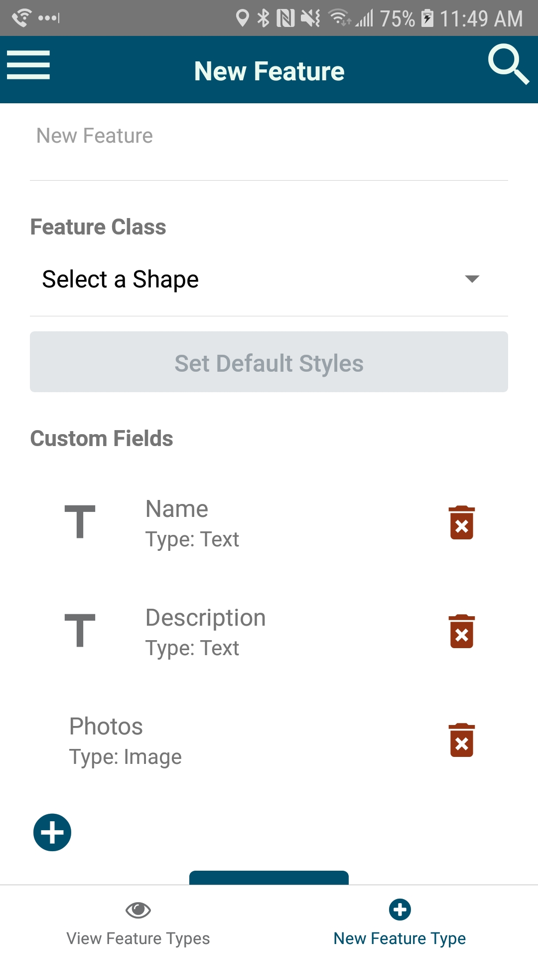

Edit or delete a User Defined Feature Type
- Navigate to the “User Defined Feature Types” screen
- Tap the ellipses to the right of the feature you’d like to edit:
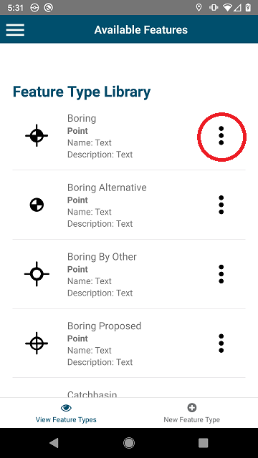
- Select edit or delete to change the user defined feature.

Measurement tools
GeoGrab comes with several tools for measuring and tracking users. These features are outlined below.

Measure the distance to yourself
- Tap the hammer & wrench (“Tools“) icon
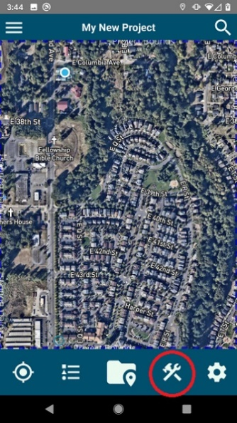
- Tap “From My Location To Another Point”. This will close the tools menu.
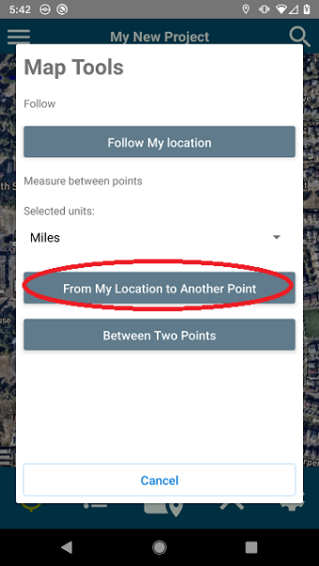
- Tap anywhere on the screen to measure the distance to yourself. The distance will appear at the top of the map.
- Tap the line again to remove it.

Measure the distance between two points
- Tap the “Tools” icon.
- Tap “Between Two Points”. This will close the tools menu.
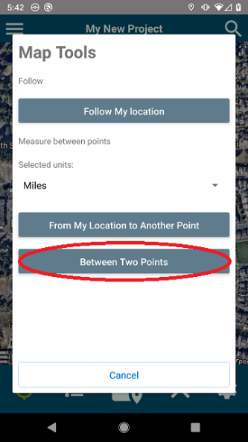
- Tap anywhere on the screen.
- Tap again to measure the distance to the second location. The distance will appear at the top of the map.
- Tap the line again to remove it.

Create a line following the user’s path
- Tap the “Tools” icon.
- Tap “Follow my location”. This will close the tools menu.
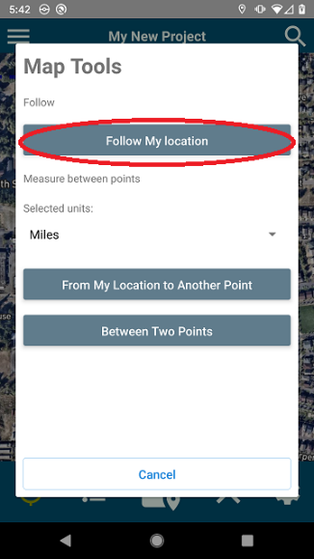
- On the bottom of the map, a “Following” message will appear.
  - WARNING: Do not close the app while this is running, location information is only captured while the application is running. (This limitation should be removed in an upcoming build of the application)
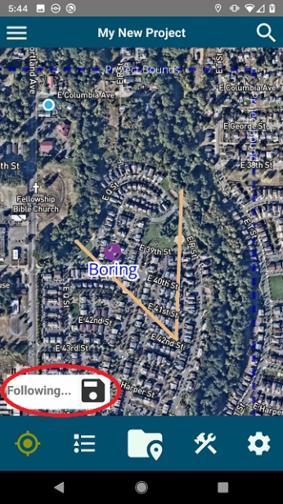
- Tap the “Save” icon to stop following the user. This will prompt you to enter a line name.
- Enter a line name. The line will be saved in the feature type layer “saved paths”.

Technical Support
If you have any questions, comments, or would like to request a new feature, you may send an email to softwareengineeringsupport@geoengingeers.com.

